**Dental Clinic Services System**

Project Management Plan

By

**Kanokwan Maneerat 542115002**

**Worapun Wongkium 542115055**

Department of Software Engineering

College of Arts, Media, and Technology

Chiang Mai University

Project Adviser

______________________________

Mrs. Yun Rim Park

**Project Management Plan**

**Revision Table**

|  |  |  |  |  |  |
| --- | --- | --- | --- | --- | --- |
| **Document Name** | **Detail** | **Status** | **Date** | **Viewable** | **Reviewer& Responsible** |
| DCSS-Management Plan-ver 0.1 |  | Draft | 04/06/2014 | Adviser | Kanokwan & Worapun |
| DCSS-Management Plan-ver 0.2 | Change Hardware and Material Resources | Draft | 04/15/2014 | Adviser | Kanokwan & Worapun |
| DCSS-Management Plan-ver 0.3 | Edit chapter four: quality standard | Draft | 04/20/2014 | Adviser | Kanokwan & Worapun |
| DCSS-Management Plan-ver 0.4 | Correct word and double check | Draft | 05/17/2014 | Adviser | Kanokwan & Worapun |
| DCSS-Management Plan-ver 0.5 | Correct grammar and add more details to the document | Draft | 05/29/2014 | Adviser | Kanokwan & Worapun |
| DCSS-Management Plan-ver 0.6 | Change schedule and milestone | Draft | 06/16/2014 | Adviser | Kanokwan & Worapun |
|  |  |  |  |  |  |
|  |  |  |  |  |  |
|  |  |  |  |  |  |

Table of Contents

Chapter One: Introduction 4

1. Introduction 4

1.1 Project Overview 4

1.2 Document overview 4

1.3 Work product to be develop 5

1.4 Acronyms 5

Chapter Two: Infrastructure 8

2. Infrastructure 8

2.1 Software development life cycle 8

2.2 Development Tools 8

2.3 Hardware and Material Resources 8

Chapter Three: Management Procedures 10

3. Management Procedures 10

3.1 Project Team Structure 10

3.2 Monitoring and Controlling Mechanism 10

3.2.1 Project Meeting 10

Chapter Four: Quality Standard 11

4. Quality Standard 11

Chapter Five: Quality Planning 13

5. Quality Planning 13

Chapter Six: Estimated Duration of Tasks 14

6. Estimated Duration of Tasks 14

6.1 Review/Responsibility 14

6.2 Testing 14

6.3 Estimated Effort and Cost 14

Chapter Seven: Version Control Strategy 19

7. Version control strategy 19

7.1 Filename format 19

7.2 Change Management 19

7.3 Project Repository 19

7.4 Software Configuration Item Table 20

Chapter Eight: Risk Management 21

8. Risk Management 21

8.1 Risk Management Process 21

# 

# Chapter One: Introduction

## 1. Introduction

Dental clinic service system is created for reducing officers’ work and make convenient for the patients. This project will provide the dental clinic schedule for patients, officers and dentists. All of them can manage their time by themselves. For example, patients can reserve date/time to make an appointment date. Each of the users has limited functionalities allowed for each user type such as patients cannot change the dentists' appointments.

## 1.1 Project Overview

Dental clinic service system is a mobile application on iOS and web application creating for three kinds of users: patients, officers, and dentists. This project will manage the patient appointment date and dentist schedule treatment. It can scan QR code from patients to identify to solve the problem that patients often lose their appointment card. It has a reminder function for patients about their appointment date to solve the problem that patients always call for asking their appointment date from officers.

### 1.1.1 Purpose

This project management plan is a document for planning, scheduling, activities and evaluating overall of the project so the project for managing and avoid the risk that can occur in the project. The project will complete as successful as possible.

### 1.1.2 Scope

Dental clinic service system is mobile application and web application to develop for small dental clinic. This application helps to manage the patients’ appointment date and appointment remind. The reminder function is included in the mobile application. For the patient who does not use a smart phone the system will send a notification in sms. It can generate the patients’ ID in the QR code to identify patient do not to bring the appointment card to the dental clinic and send the QR code by using email, mobile application. The officer and dentist can create, change, and edit and delete the patients’ schedule. This application is proportion of works under ISO 29110

## 1.2 Document overview

The purpose of the Dental clinic service system plan is guide team members management while developing the Dental clinic service system mobile application and web application.

## 1.3 Work product to be develop

### 1.3.1 Deliverables

|  |  |  |  |  |
| --- | --- | --- | --- | --- |
| **No.** | **Deliverables/Release** | **Media** | **No. of copies** | **Date** |
| 1 | **Project Proposal**   * Dental clinic service system | Document | 3 |  |
| 2 | **Progress Report 1**   * Software project management plan version * Software requirement specification version * Software design document version * Test plan version * Test record version * Traceability record version | Document  Document  Document  Document  Document  Document | 3  3  3  3  3  3 |  |
| 3 | **Progress Report 2**   * Software project management plan version * Software requirement specification version * Software design document version * Test plan version * Test record version * Traceability record version | Document  Document  Document  Document  Document  Document | 3  3  3  3  3  3 |  |
| 4 | **Progress Report 3**   * Software project management plan version * Software requirement specification version * Software design document version * Test plan version * Test record version * Traceability record version | Document  Document  Document  Document  Document  Document | 3  3  3  3  3  3 |  |

## 

## 1.4 Acronyms

### 1.4.1 Acronyms

|  |  |
| --- | --- |
| **Acronyms** | **Stands for** |
| PM | Project Management |
| PMP | Project Management Plan |
| URS | User Requirement Specification |
| SRS | Software Requirement Specification |
| VSE | Very Small Entity |
| QR code | Quick Response Code |

### 1.4.2 Definition

Acceptance test Test activities for sample checks to verify a system (or product, solution) has the right quality for deployment or usage. Often acceptance test is done by customer [IEEE90]

Feature Transformation of input parameters to output parameters based on specified algorithm. It describes the functionality of the product. Used for requirements analysis, design, coding, testing or maintenance. [IEEE90]

IEEE Institute for electrical and electronic engineers. Biggest global interest group for engineers of different branches and computer scientist [IEEE90]

Plan A documented series of task requires meeting an objective, typically including the associated schedule, budget, resources, organizational, description and work breakdown structure [IEEE90]

Project Management The application of knowledge, skills, tools, and techniques to project activities in order to meet or exceed stakeholder needs and expectations from a project [IEEE90]

Project Plan A formal, approved document used to guide both project execution and project control. The primary uses of the project plan are to document planning assumptions and the decision, to facilitate communication among stakeholders, and to document approved scope, scope, cost, and schedule baseline. [IEEE90]

Risk An uncertain event or condition that, if it occurs, has a positive or negative effect on a project’s objectives. It is a function of the probability of occurrence of a given threat’s occurrence. [IEEE90]

Risk Management The systematic application of management policies, procedures and practices to the tasks of identifying, analyzing, evaluating, treating and monitoring risk. [IEEE90]

Traceability The ability to trace the history, application or location of an item or activities, by means of recorded identification. The establishment and maintenance of relationships between such items. Horizontal traceability describes the relationship between work products of the same type (e.g. customer requirement). Vertical traceability describes the relationship between work products, which build upon each other or derived from each other (e.g. from customer requirements to qualification test cases). Bidirectional traceability allows to directly following relationships in both directions. [IEEE90]

Unit test A test of individual programs or modules in order to remove design or programming errors. [IEEE90]

Validation Confirmation by examination and provision of objective evidence that the particular requirements for a specific intended use a fulfilled (“doing the right thing”).Part of quality control.

Verification Confirmation at the end of the process by examination and provision of objective evidence that specified requirements to the process has been fulfilled (“doing things right”). Part of quality control. [IEEE90]

QR code two-dimensional barcodes that can be read by many cell phones and smartphones. The codes, which are small squares with black and white patterns, appear in a variety of places, such as magazine and newspaper ads. A QR code is used to encode some sort of information, such as text or a URL.

**Chapter Two: Infrastructure**

## 2. Infrastructure

## 2.1 Software development life cycle

Iterative and Incremental development is a process that separates the large feature into small chucks. The iterative development, the implementation design, developed and test will repeat in cycle. In each iteration, addition features can be design to add in designed, developed and tested until there is a fully functional software application ready to be deployed to customers.

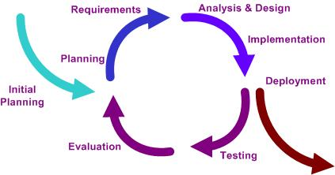

Figure 1: Iterative and Incremental Development model

Dental clinic services system is using iterative and incremental because this process can reduce the risk that may occur and simplicity to use. Iterative developing can fulfill and change software and the documents in each progress.

## 2.2 Development Tools

* **CodeIgniter version 2.1.4**

CodeIgniter is an open source web application development framework. CodeIgniter allows user to use both HTML and PHP language and also support fully MVC pattern.

* **Xcode version 5.0**

Xcode is an IDE for developing software for iOS and OSX, contains iOS simulator for developing iPhone and iPad application.

* **PhoneGap version 2.9.1**

PhoneGap is a free open source that allow user to create hybrid mobile application by using HTML5.

* **MySQL server**

We use PhpMyAdmin 2.10.3 for database because it supports a wide range in MySQL, easy to use and it is free tools.

* **Adobe Dreamweaver CC**

Dreamweaver is the development tools that use to create HTML and PHP webpage from Adobe.

## 2.3 Hardware and Material Resources

* **Computer**
* **Dell Inspiron N4110**

**Processor:** Intel(R) Core(TM) i3-2310M CPU@ 2.10GHz, 2.10 GHz

**Memory:** 6.00 GB

**Operating system:** Window 7 Ultimate

* **Sony VAIO SVE14118FHB**

**Processor:** Intel(R) Core(TM) i7-3612QM CPU@ 2.10GHz, 2.10 GHz

**Memory:** 8.00 GB **Operating system:** Windows 7 Home Premium

* **MacBook Pro**

**Processor:** 2.5 GHz Intel Core i5

**Memory:** 4 GB 1600 MHz DDR38.00 GB

**Operating system:** W OS X 10.9.2 (13C1021)

* **iPhone**
* **iPhone 5s**

**Processor:** Dual core, 1300 MHz

**Memory:** 32 GB internal storage, 1 GB RAM DDR3

**Operating** System: iOS7

# Chapter Three: Management Procedures

## 3. Management Procedures

## 3.1 Project Team Structure

|  |  |  |
| --- | --- | --- |
| **Responsibility** | **Owner** | **Reviewer** |
| Project proposal | Kanokwan & Worapun | Kanokwan & Worapun |
| Project plan and Quality plan | Kanokwan & Worapun | Kanokwan & Worapun |
| Requirement specification | Kanokwan & Worapun | Kanokwan & Worapun |
| Design document | Kanokwan & Worapun | Kanokwan & Worapun |
| Test Plan | Kanokwan & Worapun | Kanokwan & Worapun |
| Tractability record | Kanokwan & Worapun | Kanokwan & Worapun |
| Testing record | Kanokwan & Worapun | Kanokwan & Worapun |

## 3.2 Monitoring and Controlling Mechanism

### 3.2.1 Project Meeting

|  |  |
| --- | --- |
| **Participants** | **Roles** |
| MissKanokwan Maneerat | Development team member |
| Miss Worapun Wongkium | Development team member |
| Mrs. Yun Rim Park | Project Advisor |

# Chapter Four: Quality Standard

## 4. Quality Standard

**4.1 ISO29110 for Very Small Entity (VSE)**

## The ISO29110 contain 2 processes are Project management and Software implementation.

**4.1.1 Project Management (PM) process**

* **PM purpose**

The purpose of the Project Management process is to establish and carry out in a systematic way the tasks of the software implementation project, which allows complying with the project’s objectives in the expected quality, time and costs.

* **PM objectives** 
  + ***PM.O1:***The Project Plan for the execution of the project is developed according to the Statement of Work and validated with the Customer. The tasks and resources necessary to complete the work are sized and estimated
  + ***PM.O2:***Progress of the project is monitored against the Project Plan and recorded in the Progress Status Record. Corrections to remediate problems and deviations from the plan are taken when project targets are not achieved. . Appropriate treatment is taken to correct or avoid the impact of risk. Closure of the project is performed to get the Customer acceptance documented in the Acceptance Record.
  + ***PM.O3:*** The Change Requests are addressed through their reception and analysis. Changes to software requirements are evaluated for cost, schedule and technical impact.
  + ***PM.O4:*** Review meetings with the Work Team and the Customer are held. Agreements are registered and tracked.
  + ***PM.O5:*** Risks are identified as they develop and during the conduct of the project.
  + ***PM.O6:*** A software Version Control Strategy is developed. Items of Software Configuration are identified, defined and baselined. Modifications and releases of the items are controlled and made available to the Customer and Work Team including the storage, handling and delivery of the items.
  + ***PM.O7:*** Software Quality Assurance is performed to provide assurance that work products and processes comply with the Project Plan and Requirements Specification.

* **PM Activities**

The Project Management Process has the following activities:

- PM.1 Project Planning

- PM.2 Project Plan Execution

- PM.3 Project Assessment and Control

- PM.4 Project Closure

**4.1.2 Software Implementation (SI) process**

* **SI purpose**

The purpose of the Software Implementation process is the systematic performance of the analysis, design, construction, integration and tests activities for new or modified software products according to the specified requirements.

* **SI objectives**
* ***SI.O1:*** Tasks of the activities are performed through the accomplishment of the current Project Plan.
* ***SI.O2:*** Software requirements are defined, analyzed for correctness and testability, approved by the Customer, baselined and communicated.
* ***SI.O3:*** Software architectural and detailed design is developed and baselined. It describes the software items and internal and external interfaces of them. Consistency and traceability to software requirements are established.
* ***SI.O4:*** Software components defined by the design are produced. Unit test are defined and performed to verify the consistency with requirements and the design. Traceability to the requirements and design are established.
* ***SI.O5:*** Software is produced performing integration of software components and verified using Test Cases and Test Procedures. Results are recorded at the Test Report. Defects are corrected and consistency and traceability to Software Design are established.
* ***SI.O6:*** A Software Configuration that meets the Requirements Specification as agreed to with the Customer, which includes user, operation and maintenance documentations is integrated, baselined and stored at the Project Repository. Needs for changes to the Software Configuration are detected and related Change Requests are initiated.
* ***SI.O7:*** Verification and Validation tasks of all required work products are performed using the defined criteria to achieve consistency among output and input products in each activity. Defects are identified, and corrected; records are stored in the *Verification/Validation Results.*

* **SI activities**

The Software Implementation Process has the following activities:

- SI.1 Software Implementation Initiation

- SI.2 Software Requirements Analysis

- SI.3 Software Architectural and Detailed Design

- SI.4 Software Construction

- SI.5 Software Integration and Tests

- SI.6 Product Delivery

# Chapter Five: Quality Planning

## 5. Quality Planning

**5.1 Quality Factor**

**Product operation factors**

* Correctness

The software product should be able to provide 100% correctness of data from user request.

* Reliability

The software product should be able to handle more than 90% of activity with less than 10% of software failure.

* Integrity

The software product should be able to identify users which are patient, officer, and dentist.

* Usability

User who use software product at first time should be able to use all features within 30 minutes.

**Product revision factors**

* Maintainability

The software product should have 15-20% of comment comparing with the whole LOC.

* Testability

The software product should be able to test 100% of it defined routine and functionality.

**Product transition factors**

* Reusability

More than 30% part of finished software product should be able to reuse in future development.

# Chapter Six: Estimated Duration of Tasks

## 6. Estimated Duration of Tasks

## 6.1 Review/Responsibility

|  |  |  |  |  |
| --- | --- | --- | --- | --- |
| **Stage Exit Review** | | | | |
| **No.** | **Stage** | **Review Item** | **Owner** | **Reviewer** |
| 1 | Progress #1 | Software project management plan | Kanokwan & Worapun | Kanokwan & Worapun |
| 2 | Progress #1 | Software requirement specification | Kanokwan & Worapun | Kanokwan & Worapun |
| 3 | Progress #1 | Software design document | Kanokwan & Worapun | Kanokwan & Worapun |
| 4 | Progress #1 | Test plan | Kanokwan & Worapun | Kanokwan & Worapun |
| 5 | Progress #1 | Test record | Kanokwan & Worapun | Kanokwan & Worapun |
| 6 | Progress #1 | Traceability record | Kanokwan & Worapun | Kanokwan & Worapun |

## 6.2 Testing

|  |  |  |
| --- | --- | --- |
| **Test Process** | | |
| **No.** | **Test** | **Participation** |
| 1 | Unit testing | Kanokwan & Worapun |
| 2 | Integration testing | Kanokwan & Worapun |
| 3 | Acceptance Testing | Kanokwan & Worapun |

## 6.3 Estimated Effort and Cost

## Estimate effort and cost of Dental clinic service system have:

* Rent the web server
* Register for Apple developer
* Webcam QR code scanner

**6.4 Schedule & Milestone**

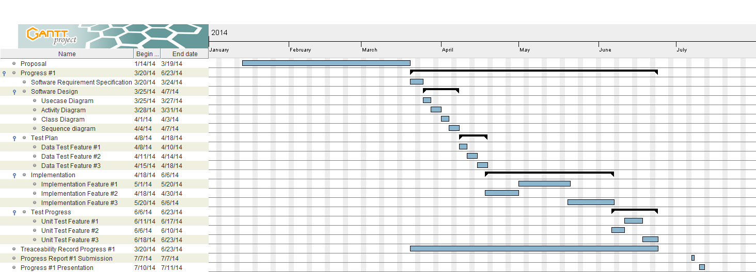

Figure 2: Milestone of Proposal and Progress 1

As shown in Figure 2, the proposal stage starts around January and continues until the mid-March.

Progress 1 starts around mid-March until July.

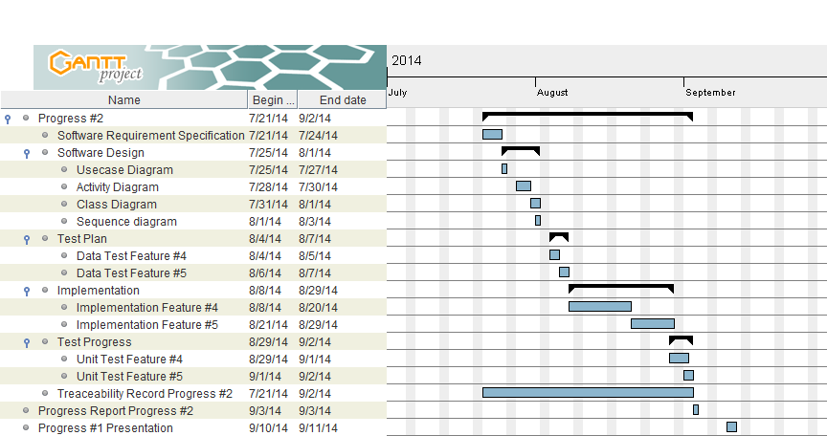

Figure 3: Milestone of Progress 2

As shown in Figure 3, Progress 2 starts around mid- July and continues until mid-September.

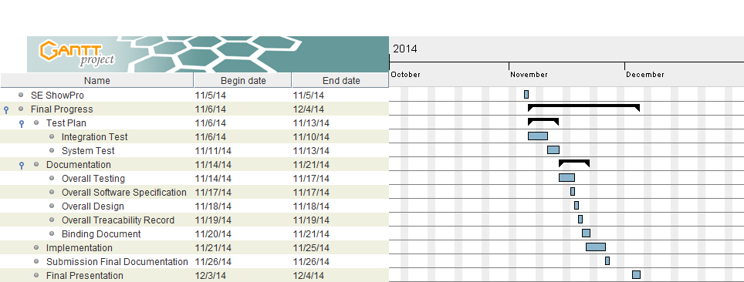

Figure 5: Milestone of SE ShowPro and Final Progress

As shown in Figure 5, SE ShowPro is 5th November 2014.

Final progress is from after ShowPro day continues until December.

# Chapter Seven: Version Control Strategy

## 7. Version control strategy

## 7.1 Filename format

The filename format which use for all project document is

* [Project name]-[Document name]_[Version].file type

## 7.2 Change Management

Change management are management all of changes in the project during development process. All of change request will be recorded to the change request document.

* The strategy for manage the changes following these steps :
* Analyze for changing
* Make a conclusion from change request
* Approve the change request by project advisor
* Change the project follows by approve change request

## 7.3 Project Repository

* **Github**

GitHub is a [web-based hosting service](http://en.wikipedia.org/wiki/Shared_web_hosting_service) for software development projects that use the [Git](http://en.wikipedia.org/wiki/Git_%28software%29) [revision control](http://en.wikipedia.org/wiki/Revision_control) system. The site provides [social networking](http://en.wikipedia.org/wiki/Social_networking) functionality such as feeds, followers, wikis and the [social network graph](http://en.wikipedia.org/wiki/Social_network_graph) to display how developers work on their versions of a repository.

Github is a tool that can help to manage the version of document and software. We can share file or update version of file in the time with team member. This tool is very easy to use. Github can create own folder in Github folder and share this folder to anyone in team meber and advisor.

## 7.4 Software Configuration Item Table

|  |  |  |  |  |  |  |
| --- | --- | --- | --- | --- | --- | --- |
| **No.** | **Item** | **File name** | **File Type** | **Owner** | **Path** | **Baseline version** |
| 1 | Project proposal | Dental Clinic Services System – Proposal – v 1.2 | .docx | Kanokwan&Worapun | C:\Users\Dell\Documents\GitHub\seniorproject\proposal\document | 1.2 |
| 2 | Project management plan | Dental Clinic Services System – Management plan – v 1.0 | .docx | Kanokwan&Worapun | C:\Users\Dell\Documents\GitHub\seniorproject\progress1 | 1.0 |
| 3 | Software requirement Specification | Dental Clinic Services System –SRS– v 1.0 | .docx | Kanokwan&Worapun | C:\Users\Dell\Documents\GitHub\seniorproject\progress1 | 1.0 |
| 4 | Software design document | Dental Clinic Services System –Design– v 1.0 | .docx | Kanokwan&Worapun | C:\Users\Dell\Documents\GitHub\seniorproject\progress1 | 1.0 |
| 5 | Test plan | Dental Clinic Services System –Test plan– v 1.0 | .docx | Kanokwan&Worapun | C:\Users\Dell\Documents\GitHub\seniorproject\progress1 | 1.0 |
| 6 | Test Record | Dental Clinic Services System –Test record– v 1.0 | .docx | Kanokwan&Worapun | C:\Users\Dell\Documents\GitHub\seniorproject\progress1 | 1.0 |
| 7 | Traceability record | Dental Clinic Services System –Traceability record– v 1.0 | .docx | Kanokwan&Worapun | C:\Users\Dell\Documents\GitHub\seniorproject\progress1 | 1.0 |

# Chapter Eight: Risk Management

## 8. Risk Management

Risk management is concerned with identifying risks and plans to minimize their effect on the project such as scope or complexity.

* Define the Risk Management Process
* Identify Risks
* Perform a Quantitative and Qualitative Risk Assessment
* Create a Risk Response Plan
* Monitor Risk

All identified risk are documented in the Risk Management Process by the Project Team. In the Risk Management Process defines the possible risk and solution of them, and who responsible for.

## 8.1 Risk Management Process

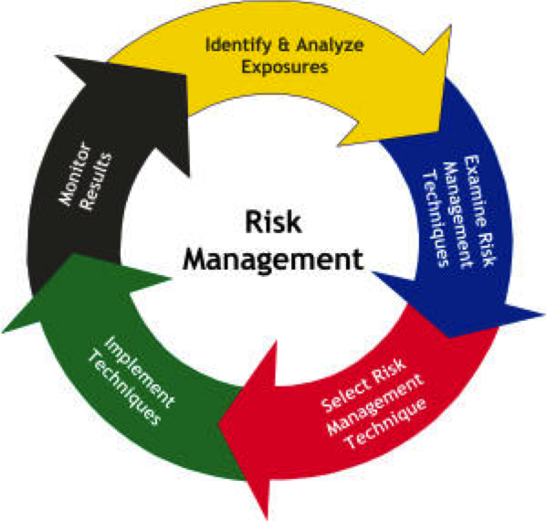 Figure 6: Risk Management Process Model

As shown in Figure 6, Start with Identify and Analyze the risk. Than examine risk management, select risk management technique, implement that technique and monitor the result.